**ARCHITECTURE AND DESIGN**

1. Data Flow Diagrams

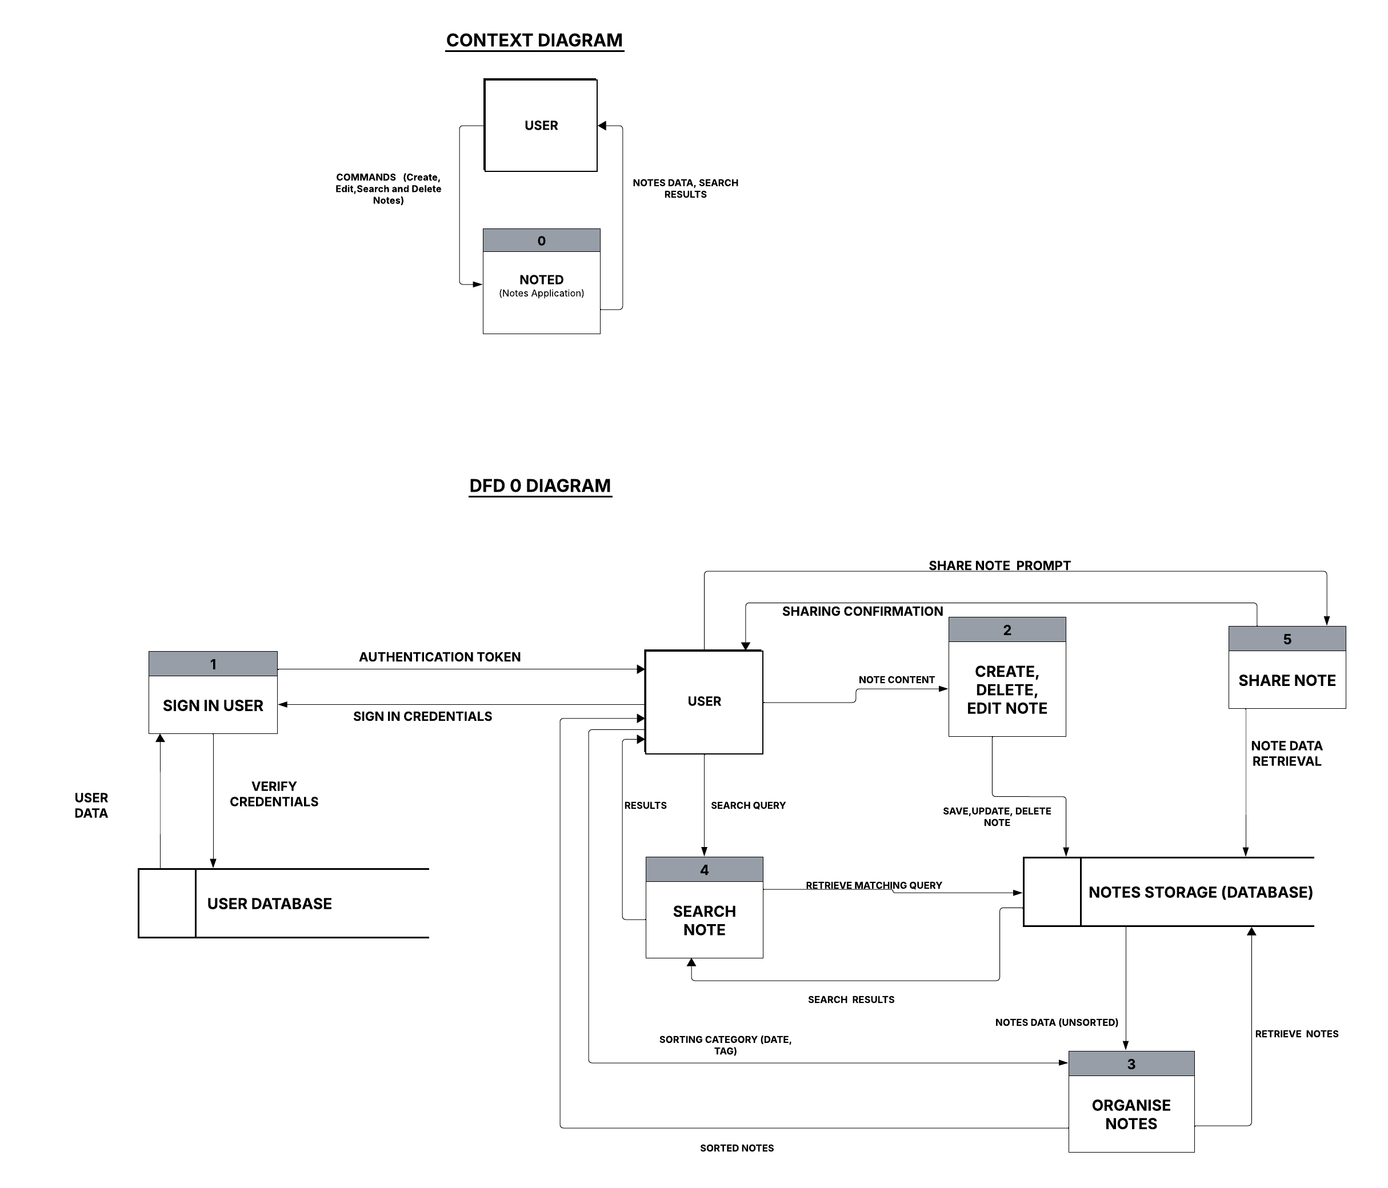

1. Class Diagram

